
Experiment (11)

Virtual Local Area Network (VLAN)
  - Objectives

To achieve Importance Of VLAN

  - Equipment / Program Requirements:
eNSP
Cisco Packet Tracker

  - Experiment Setup:
Draw your topo
Then make configuration Then display vlans in topology
  - Simulation Results:

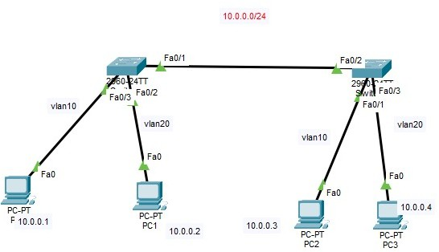
Cisco Packet Tracker: Topology:

SW 0:

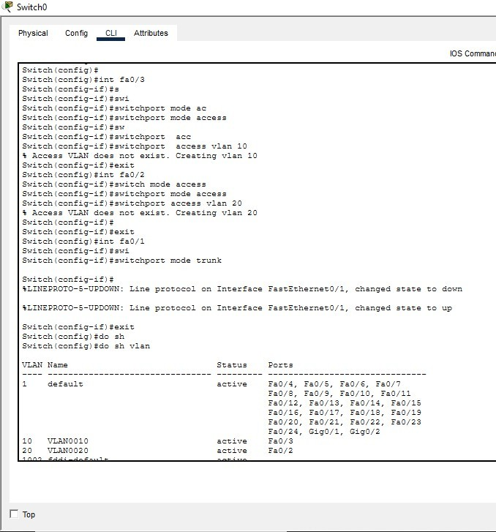

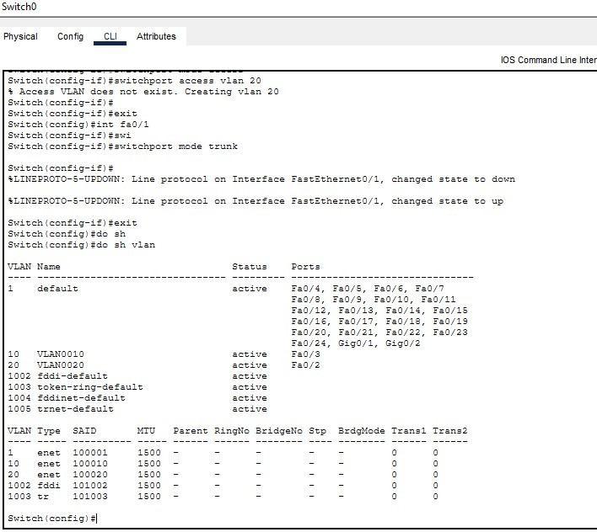

SW1:

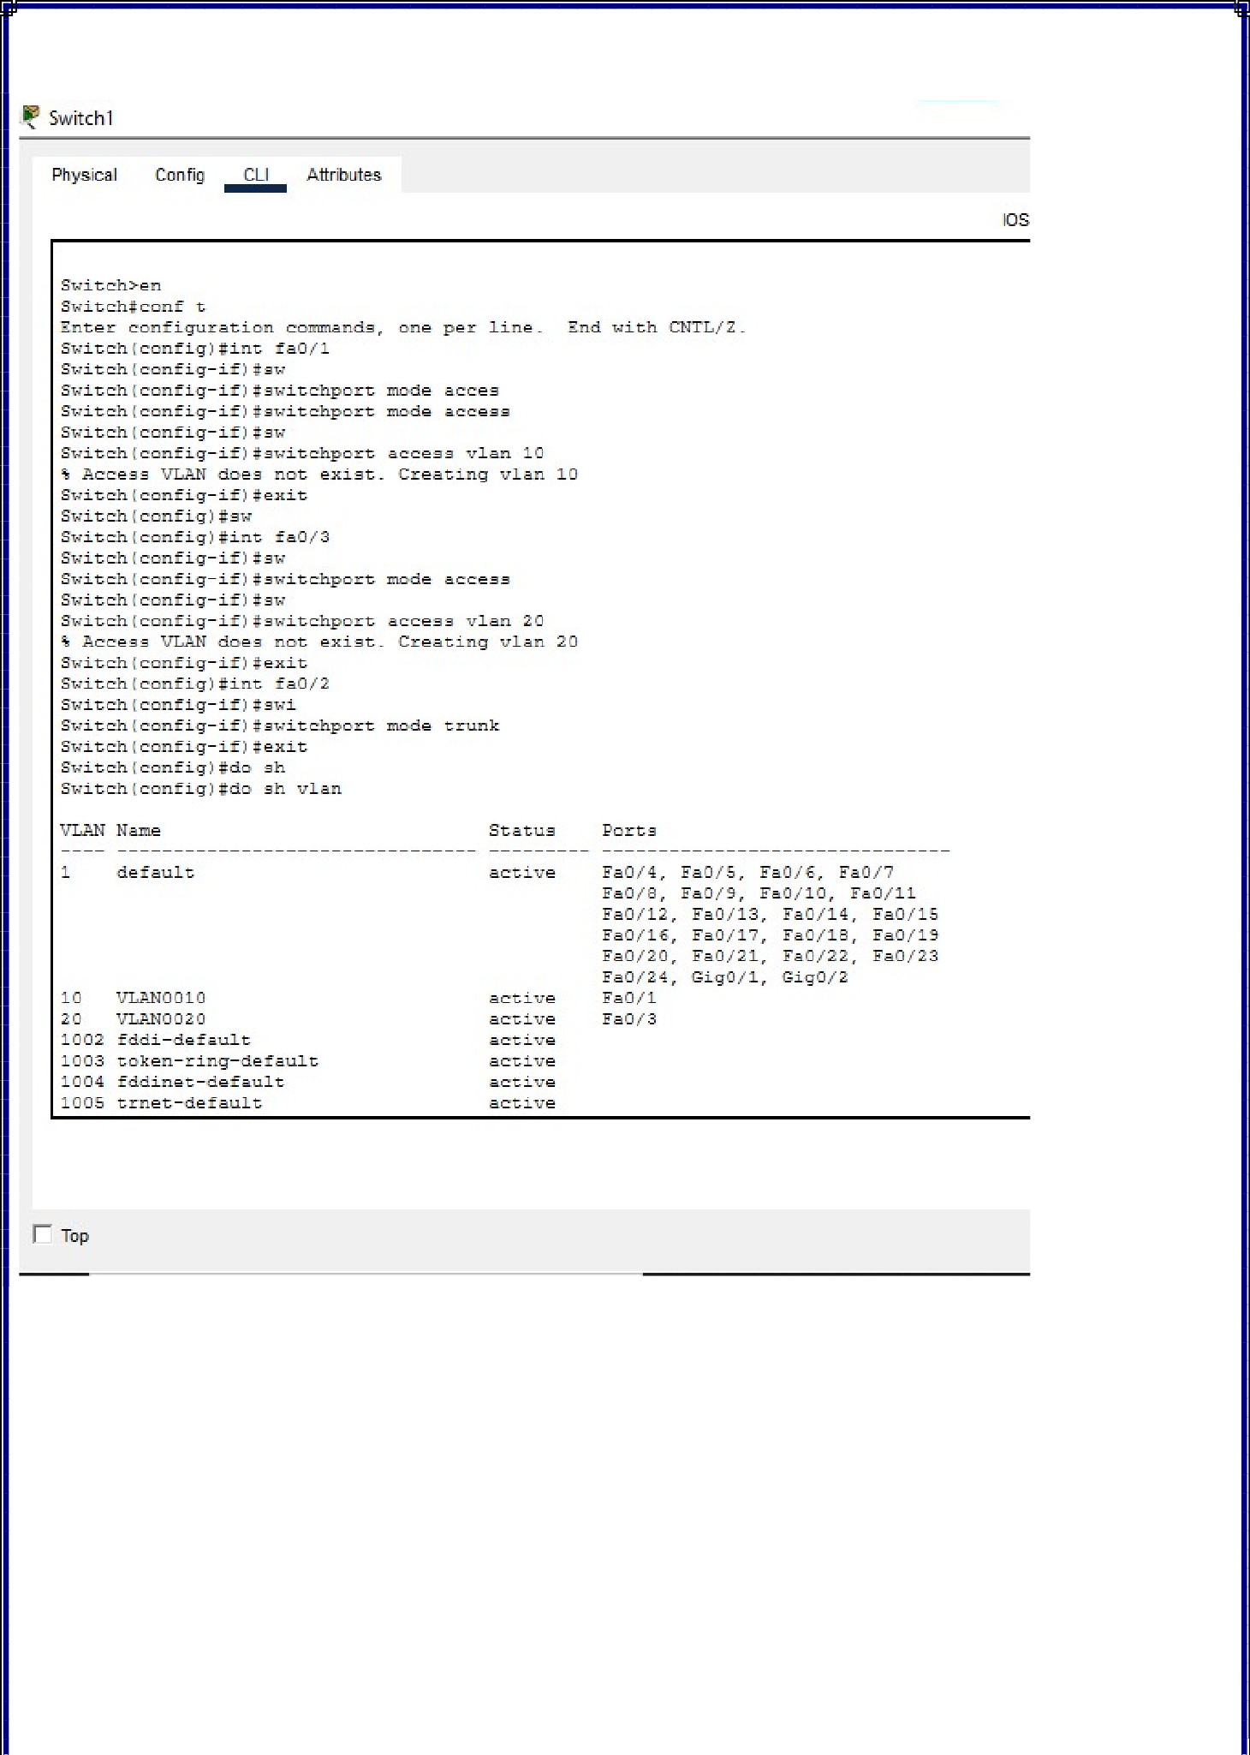

Testing:

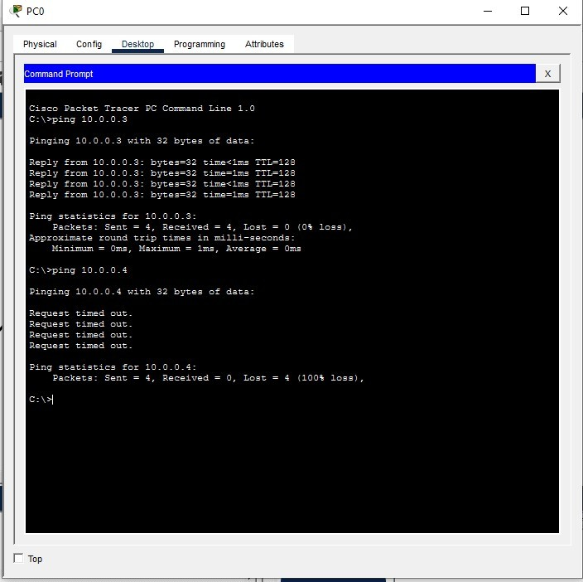

eNSP:
Topology:

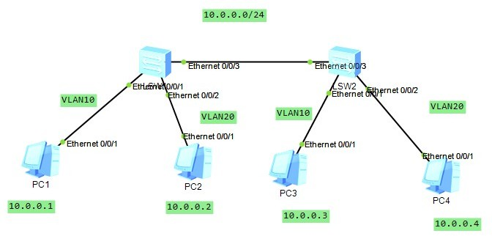

SW1:

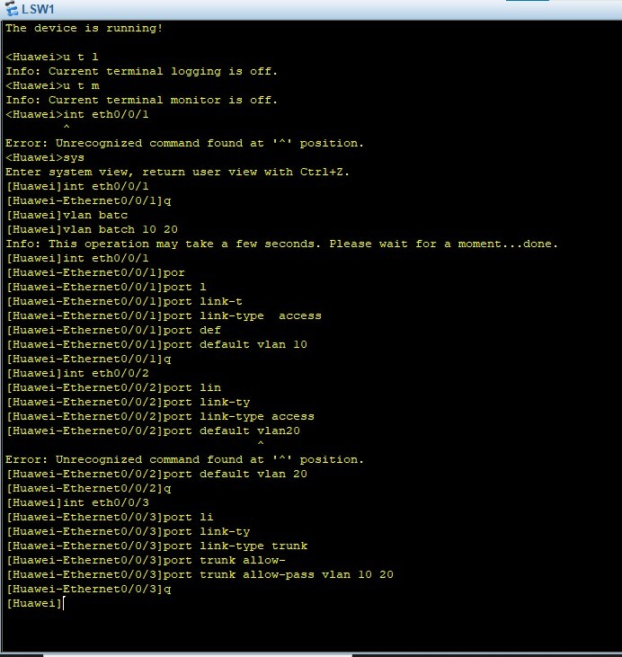

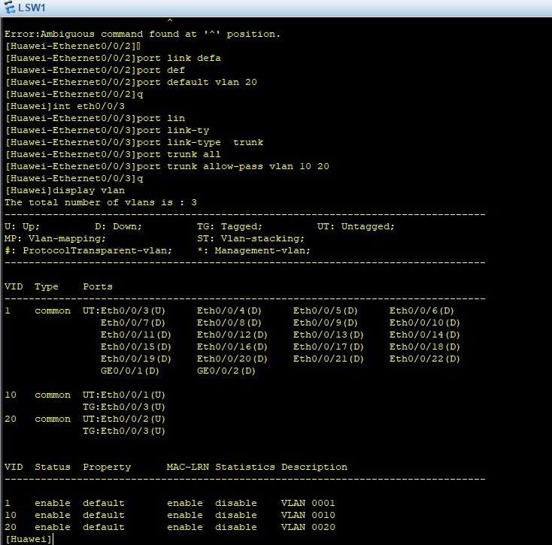

SW2:

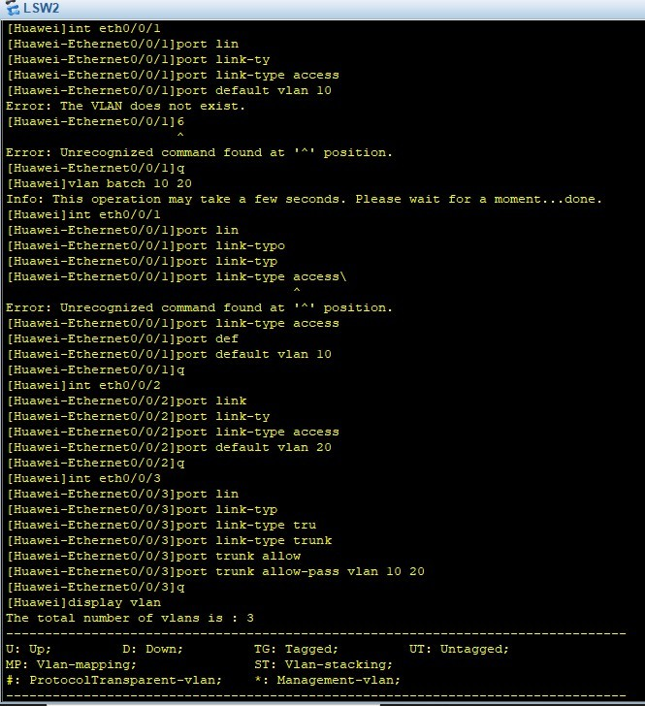

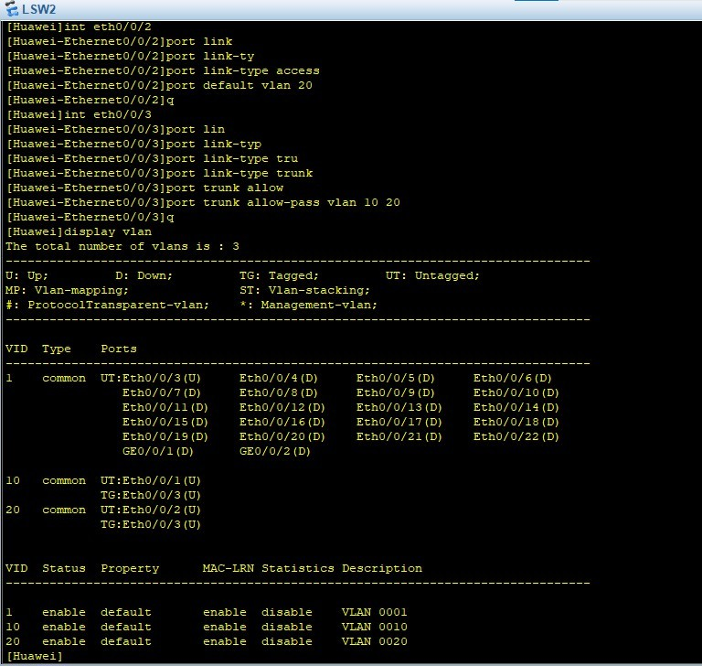

Testing:

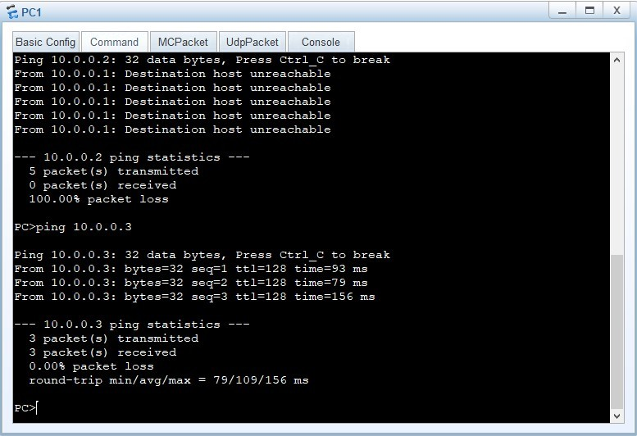

  - Conclusions:
Virtual Local Area Networks (VLANs) play a crucial role in modern network design by logically segmenting a physical network into smaller, isolated broadcast domains. This segmentation enhances network performance by reducing unnecessary traffic and improves security by restricting access between different groups of devices. VLANs also provide flexibility, allowing network administrators to organize devices based on function, department, or policy rather than physical location. Overall, VLANs contribute to efficient network management, scalability, and better control over data flow, making them an essential component in enterprise networking.

